1-Testing in the Context of a Software Development Lifecycle
Chapter 2_part 1 - start at 1:36
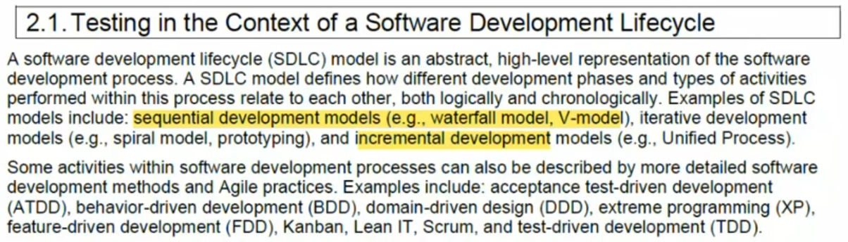

1.1-Impact of the Software Development LiveCycle on Testing
Chapter 2_part 1 - start at 9:07
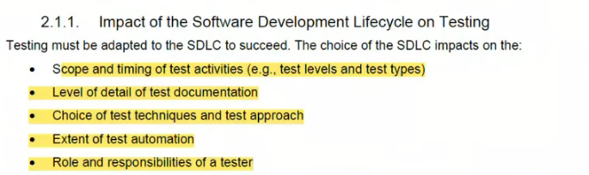
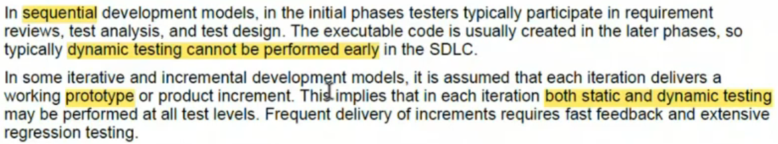
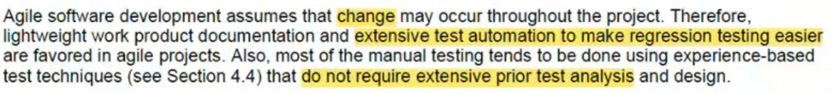

1.2- Software Development LiveCycle and Good Testing Practices
Chapter 2_part 1 - start at 14:59
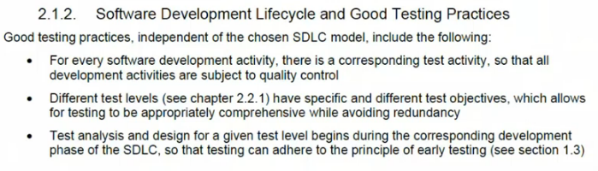
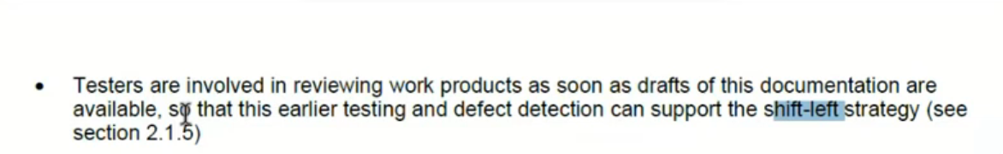

1.3-Testing as a Driver for Software Development
Chapter 2_part 1 - start at 18:20
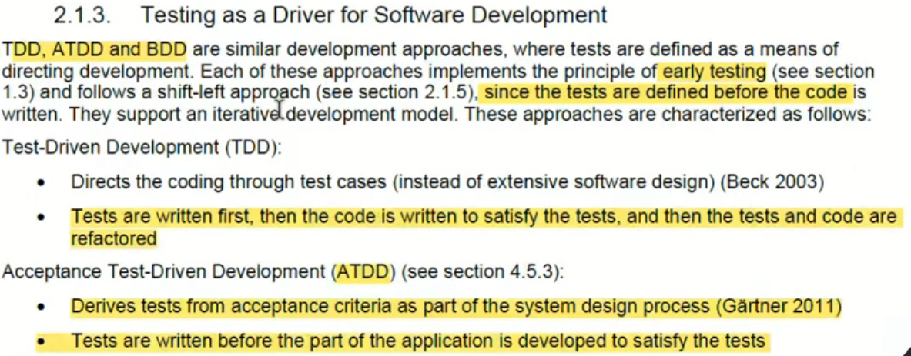
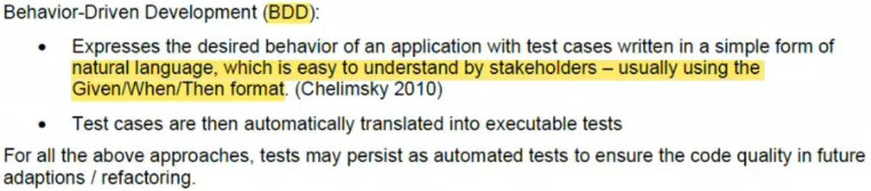

1.4-DevOps and Testing
Chapter 2_part 1 - start at 27:39
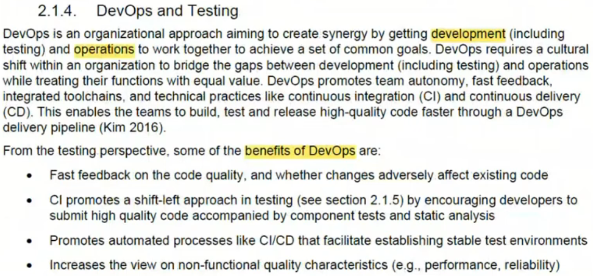
Chapter 2_ part 2 - start at 3:56
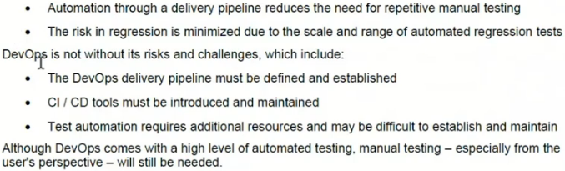

1.5-Shfit-Left Approach
Chapter 2_ part 2 - start at 5:19
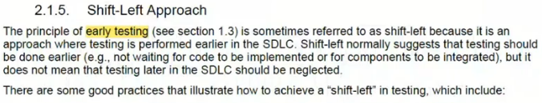
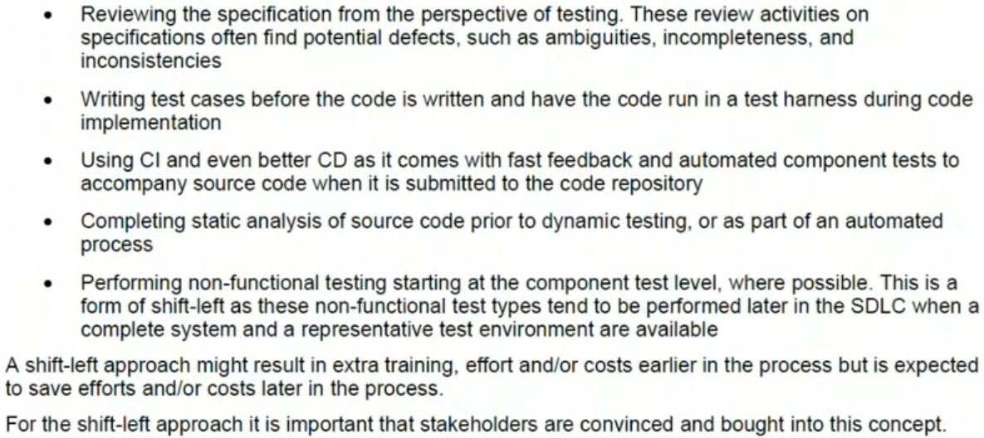

1.6-Retrospectives and Process Improvement
Chapter 2_ part 2 - start at 8:29
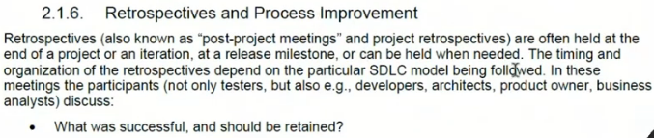
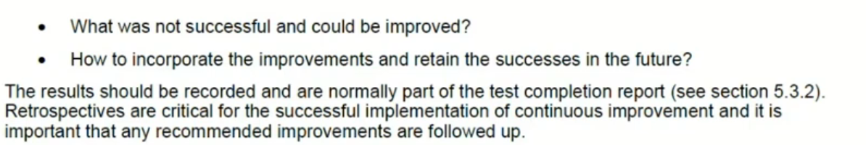
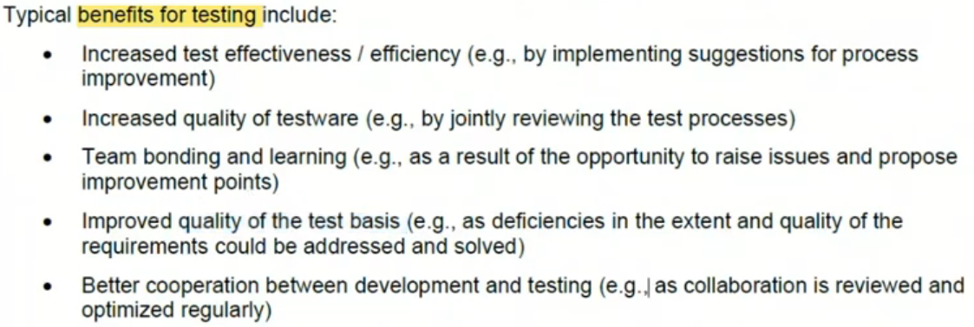

2-Test Levels and Test Types
Chapter 2_ part 2 - start at 11:27
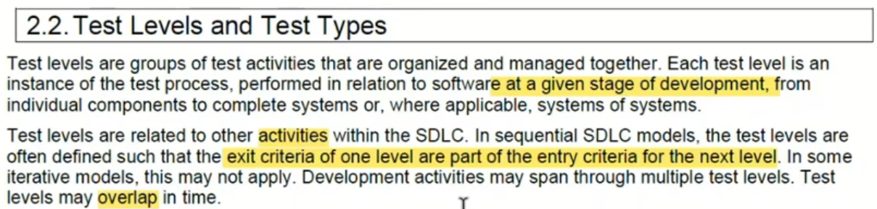

2.1-Test Levels
Chapter 2_ part 2 - start at 13:32
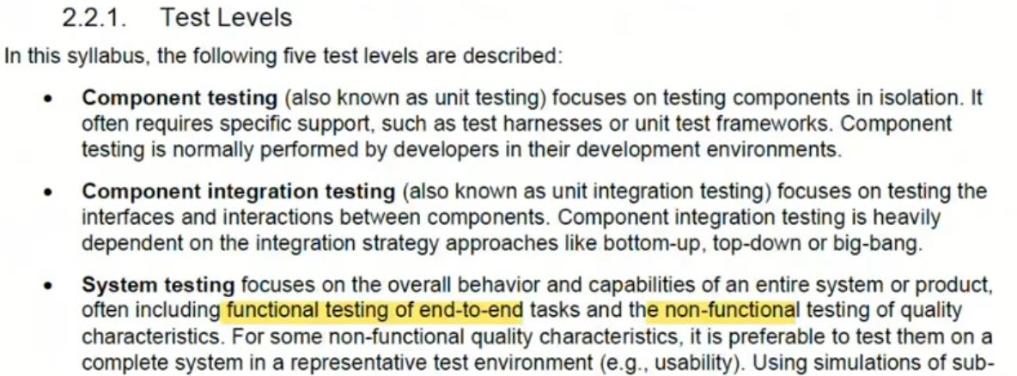
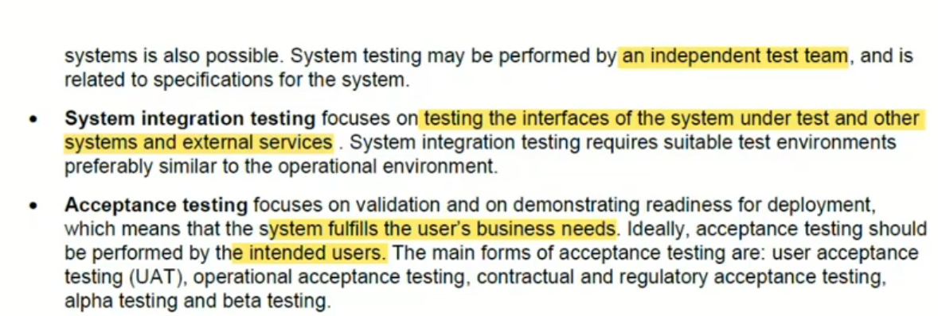
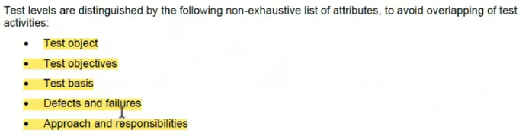

2.2-Test Types
Chapter 2_ part 2 - start at 17:27
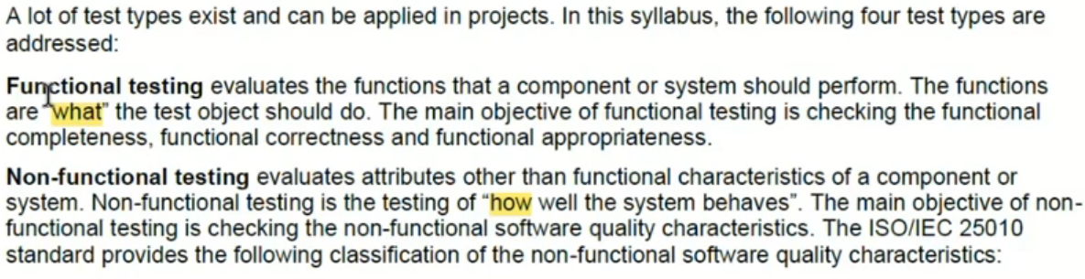
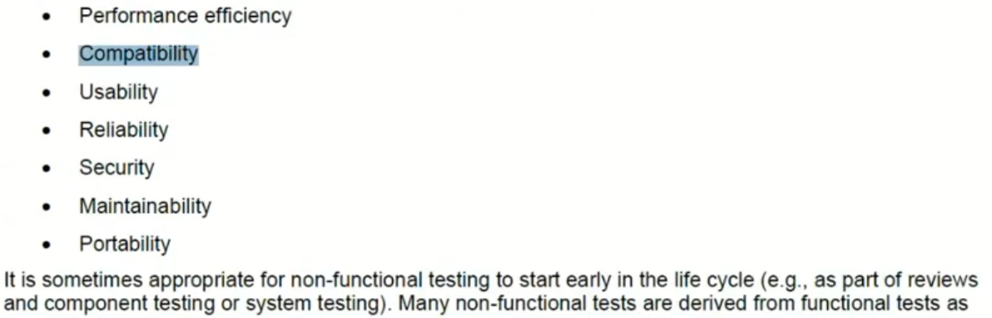

2.3-Confirmation Testing and Regression Testing
Chapter 2_ part 2 - start at 20:41
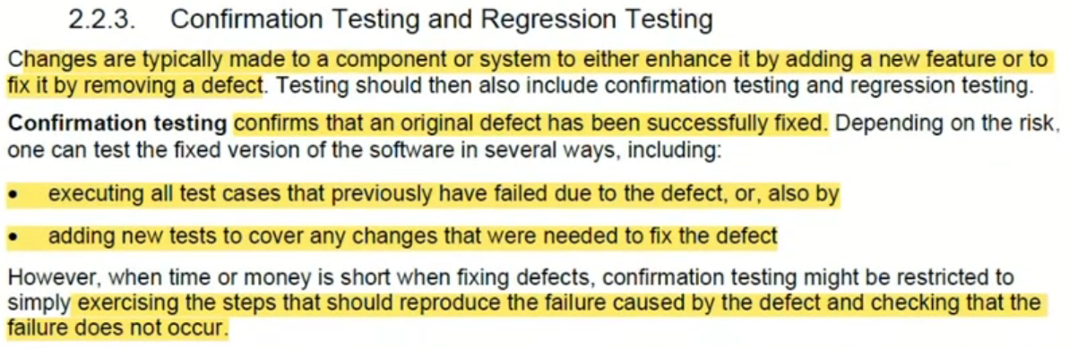
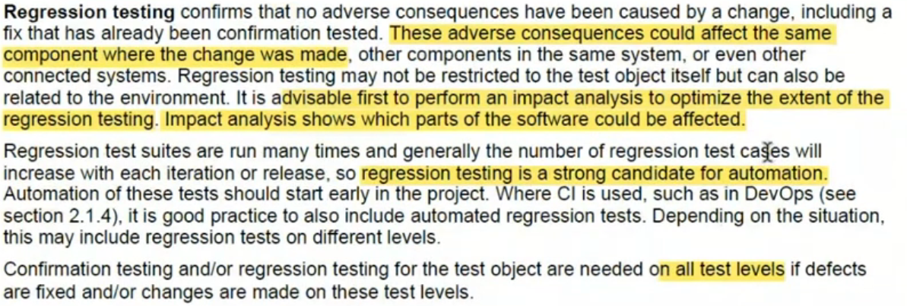

3-Maintenance Testing
Chapter 2_ part 2 - start at 23:18
